What is GDPR?
What is GDPR?
The General Data Protection Regulation is new and it helps us to keep information about you safe.
We have always looked after your information safely but GDPR helps us check we are doing the best job we can.
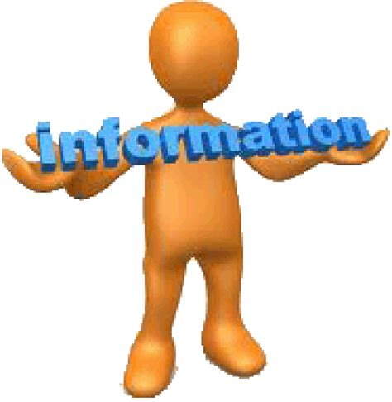 | Who looks after my information?  A person is called a ‘Data Controller’ if they look after your information  Who uses my information?  A person who uses your information for their work is called a ‘Data Processor’
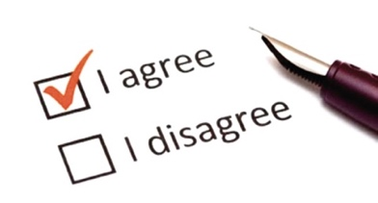  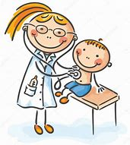 | Consent – what’s that?  Consent is where you tell us that you are happy for us to use your data to care for you. If you are under 16, a parent must give your consent for you.  Can anyone see or use my information at the Doctors?  No, only someone who needs your data to care for you is allowed to see or use it. This can be the doctors, nurses or people who support the doctors and nurses in their work.  Do you share my information with anyone else?  We only share your information with other people who might need to care for you (like the hospital) without asking you first.  If someone who isn’t responsible for your care asks for your information, we will ask your parent if it is ok to give it. An example of this might be when someone is organising an activity you would like to do and needs to check if you are well enough to do it.  Can I see the information you have about me?  If you are 13 years old or over, you can ask to see your information. Speak to a receptionist to arrange this.
 | If you still have a question, please ask the friendly receptionist who will do their best to help you.

